

EXPERIMENT REPORT

|  |  |
| --- | --- |
| **Experiment Name** | Linear Power Supplies |
| **Asistant Name** | Ayan DERYA |
| **Student**  **(Name / Number / Department)** | Alihan Polat / 040110207  /Electronics and Communication Engineering |
| **Group Number and Experiment Date** | D14-7.11.2014 |

|  |  |  |
| --- | --- | --- |
| **Report Grade** | **Delivery Date** | **Acception Date** |
|  | 14.11.2014 |  |

**EXPERIMENT 1**

**Linear Power Supplies**

**Purpose of the experiment**

To introduce basic building blocks of linear power supplies. Experimentally verify theoretical considerations.

**General Information about Linear Power Supplies**

A power supply is an electronic device that supplies electric energy to an electrical load. The primary function of a power supply is to convert one form of electrical energy to another and, as a result, power supplies are sometimes referred to as electric power converters.

* **AC-to-DC Power Supplies**

Some DC power supplies use AC mains electricity as an energy source. Such power supplies will sometimes employ a transformer to convert the input voltage to a higher or lower AC voltage. A rectifier is used to convert the transformer output voltage to a varying DC voltage, which in turn is passed through an electronic filter to convert it to an unregulated DC voltage. The filter removes most, but not all of the AC voltage variations; the remaining voltage variations are known as ripple.

The electric load's tolerance of ripple dictates the minimum amount of filtering that must be provided by a power supply. In some applications, high ripple is tolerated and therefore no filtering is required. For example, in some battery charging applications it is possible to implement a mains-powered DC power supply with nothing more than a transformer and a single rectifier diode, with a resistor in series with the output to limit charging current.

**Positive Power Supplies**

* **Switch OFF Case**

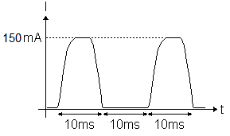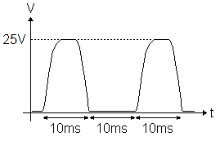With setting the IRL(DC)= 50 mA we measured the Vo(DC) = 7.98 V. We observed Vo and IRL with scope. Vo is positive half wave sinusoidal signal with 25 V maximum value. As seen at Figure-1. IRL is again positive half wave sinusoidal signal with 150 mA maximum value. As seen at Figure-2.

Figure-1 Figure-2

* **Switch ON Case**

Without making any differences with before circuit we open the switch. Therefore the circuit is full wave rectifier. We measured IRL(DC)= 100 mA and Vo(DC) = 15.95 V. Also we observed Vo(t) and IRL(t) with scope. Both of them are positive full wave sinusoidal signal. As seen at Figure-3 and Figure-4.

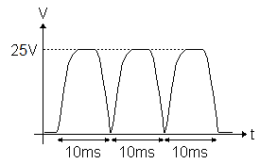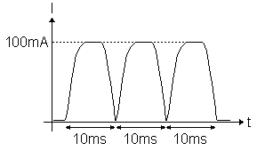

Figure-3 Figure-4

**Negative Power Supplies**

Only changing the direction of the diodes we got negative power supply.

* **Switch OFF Case**

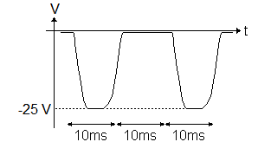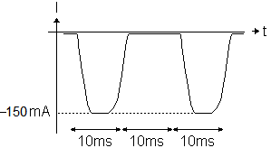 With setting the IRL(DC)= -50 mA we measured the Vo(DC) = -7.98 V. We observed Vo and IRL with scope. Vo is negative half wave sinusoidal signal with -25 V maximum value. As seen at Figure-5. IRL is again negative half wave sinusoidal signal with -150 mA maximum value. As seen at Figure-6.

Figure-5 Figure-6

* **Switch ON Case**

Without making any differences with before circuit we open the switch. Therefore the circuit is negative full wave rectifier. We measured IRL(DC)= -100 mA and Vo(DC) = -15.89 V. Also we observed Vo(t) and IRL(t) with scope. Both of them are negative full wave sinusoidal signal. As seen at Figure-7 and Figure-8.

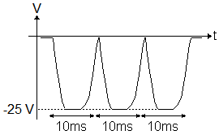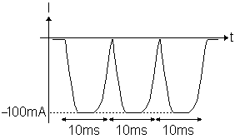Figure-7 Figure-8

**Positive Regulated Power Supplies**

We constructed the positive regulated circuit in the Lab Manuel. By changing the C1‘s (filtering capacitance) value we observed V1 and Vo .

* **C1 = 0 µF**

With setting the IRL(DC)= 100 mA we measured the Vo(DC) = 7.50 V. We observed V1 and Vo with scope. V1 is positive half wave sinusoidal signal with 25 V maximum value (Figure-9) and Vo is clipped sinusoidal signal (Figure-10).

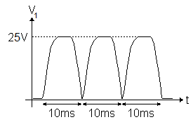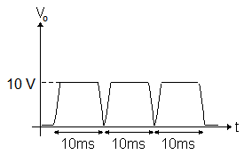

Figure-9 Figure-10

* **C1 = 470 µF**

We changed C1 to 470 µF and we measured IRL(DC)= 132.36 mA and Vo(DC) = 9.69 V. Also We observed V1 and Vo with scope. V1 is a filtered signal but it has 3 V ripple(Figure-11). Vo is pure 10 V DC signal (Figure-12).

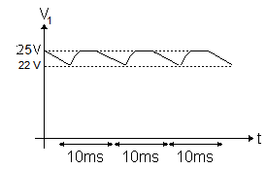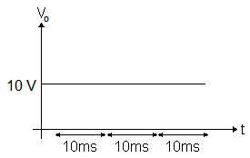

Figure-11 Figure-12

* **C1 = 4700 µF**

We changed C1 to 4700 µF and we measured IRL(DC)= 142.1 mA and Vo(DC) = 9.31 V. Also we observed V1 and Vo with scope. V1 is a filtered signal it has 0.5 V ripple (Figure-13). Vo is pure 10 V DC signal (Figure-14).

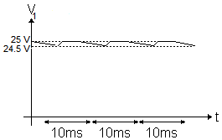

Figure-13 Figure-14

**Conclusion**

By making this experiment we had knowledge about Linear Power Supplies. And how AC signal convert to DC signal. And also we see how can we design most effective rectifier, how much affect the filtering capacitor’s value to output voltage.